**Experiment No :** 01

**Experiment Name :** Detection of radiation pattern of omni directional (dipolar) antenna.

**Apparatus Required:**

1. Antenna trainer board(DL-2595)

2. Metering Output

3. Power Supply

5. Omni Directional Antenna

**Objectives :**

**1.** To become familiar with dipole antennas.

2**.** To plot the radiation pattern of Dipole Antenna in E & H planes on log & linear scales on polar and Cartesian plots.

**3.** To measure the beam width (-3 dB), front to back ratio, side lobe level and its angular position, plane of polarization and directivity and gain of Dipole Antenna.

**Theory:**

Antennas are a fundamental component of modern communications systems. By definition, an antenna acts as a transducer between a guided wave in a transmission line and an electromagnetic wave in free space. Antennas demonstrate a property known as reciprocity that is an antenna will maintain the same characteristics regardless if it is transmitting or receiving. When a signal is fed into an antenna, the antenna will emit radiation distributed in space a certain way. A graphical representation of the relative distribution of the radiated power in space is called a radiation pattern.

The dipole antenna or dipole aerial is one of the most important and commonly used types of RF antenna. It is widely used on its own, and it is also incorporated into many other RF antenna designs where it forms the radiating or driven element for the antenna. The dipole is a simple antenna to construct and use, and many of the calculations are quite straightforward. However like all other antennas, the in-depth calculations are considerably more complicated.

P**rocedure:**

1. Mount the antenna on transmitting mast.

2. Bring the detector assembly near to the main unit and adjust the height of both Tx and Rx antennafor same.

3. Keep detector assembly away from the main unit about 1 mts and align both of them. Ensure thatthere is no reflector sort of thing in the vicinity of the experiment such as steel structure , mobile phones etc.

4. Adjust the RF detector so that deflection in detector is approx. 30-35 micro ampere.

5.Align arrow mark of the disk with zero of the goniometer scale.

6.Start taking reading at the interval of 20 degree.

7.Convert the reading into dB with the help of formula.

8.Plot polar plot with all the readings and find HPBW of antenna.

**Observation table:**

|  |  |
| --- | --- |
| Angle(~~O~~) | Signal Strength(micro A) |
| 0 | 20 |
| 20 | 18 |
| 40 | 12 |
| 60 | 4 |
| 80 | 1 |
| 100 | 0 |
| 120 | 0 |
| 140 | 0 |
| 160 | 0 |
| 180 | 2 |
| 200 | 9 |
| 220 | 19 |
| 240 | 22 |
| 260 | 19 |
| 280 | 19 |
| 300 | 9 |
| 320 | 2 |
| 340 | 0 |
| 360 | 0 |

**Code:**

>>Theta=[0,20,40,60,80,100,120,140,160,180,200,220,240,260,280,300,320,340,360];

>> A = [20,18,12,4,1,0,0,0,0,2,9,19,22,19,19,9,2,0,0];

>> polar(Theta/180*pi,A);

**Polar Diagram:**

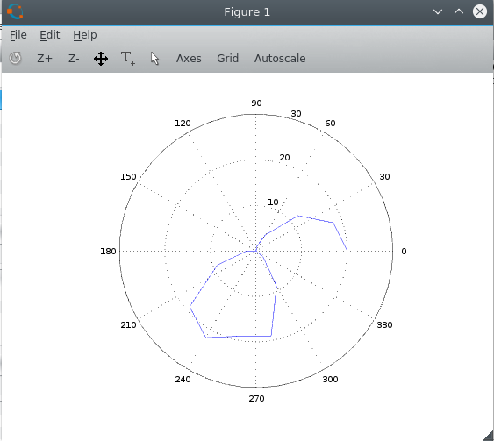

**Conclusion:**

**1.**For external noises, the graph is not completely doughnut shaped. We should keep in mind that when we are taking a reading, there should be no obstacles between the antenna and metering output.

**2.**Connection and alignment of both antennas should be make carefully.

**3.**Reading must be taken carefully.